Absolutism: Louis XIV & Peter the Great
Name: ______________________
World History
Chapter 21

- Define Absolutism

- Define Divine Right

- Generate a sentence using both terms

Louis XIV (pg. 598)
- Country:

- Background Info:

- Examples of absolutist powers:

1. | 2. | 3. | 4. | 5. | 6.

- Outcome of rule:

Peter the Great (pg. 609)
- Country:

- Background Info:

- Examples of absolutist powers:

1. | 2. | 3. | 4. | 5. | 6.

- Outcome of rule:

Determine 3 general similarities and 3 general differences between these absolute monarchs listed below.
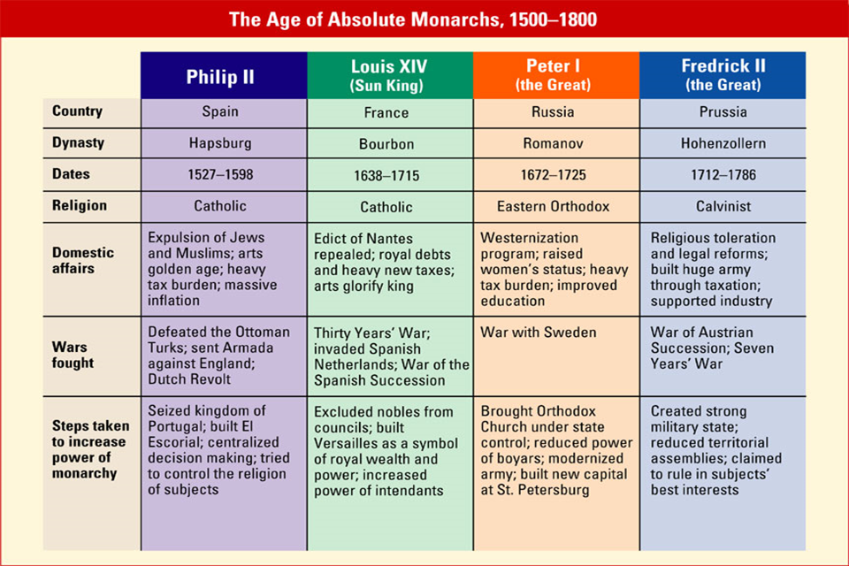
Similarities | Differences

