Religion and Politics in Asia
Classical Civilizations Name: ____________________________________
Unit One - World History

Hinduism

Key Terms
- Vedas or Vedic texts
Holy book of Hinduism
Hindus believe that the Vedas were written based on scholars direct communication with the gods and passed on to the next generations by word of mouth.
- Reincarnation
Constant death and rebirth of the soul through various forms
- Caste system
Social structure/classes
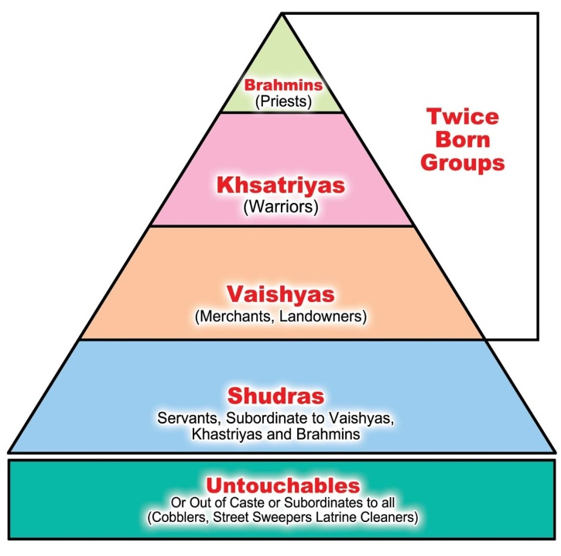
- Karma
Actions of your present life that define the outcome
of your reincarnation
- Samsara
Constant cycle of death and rebirth
- Moksha
Final release from the cycle of reincarnation
- Dharma
Your duty to your caste (ex. Born a Kshatriya = you
must be a warrior)

Dates
1500 BCE-Modern Era
Established after the Aryan invasions which ended the Indus River Valley civilization

Summary
Hinduism is the religion of the majority of people in India and Nepal. It has over 900 million adherents worldwide. Most Hindus believe in a Supreme God, whose qualities and forms are represented by the multitude of deities which emanate from him. About 80% of the Indian population regard themselves as Hindu.

Buddhism

Key Terms
- Siddhartha Gautama
  - Founder of Buddhism
- Enlightenment
  - State of perfect being - Buddha reached Enlightenment under a bodhi tree; When you reach enlightenment your soul exits reincarnation
- Reincarnation
  - Constant death and rebirth of the soul through various forms
- Nirvana
  - Final release from the cycle of reincarnation
- Eightfold Path
  - Buddha’s path to Enlightenment:
    - Right Understanding
    - Right Intention
    - Right Speech
    - Right Action
    - Right Livelihood
    - Right Effort
    - Right Mindfulness
    - Right Concentration
- Four Noble Truths
  - In life there is suffering
  - Suffering exists because of desire
  - To end suffering, we must end desire
  - To end desire, we must follow the Eightfold Path

Dates
6th century BCE

Summary
Buddhism is a spiritual tradition that focuses on personal spiritual development and the attainment of a deep insight into the true nature of life. There are 376 million followers worldwide.

Application
- Make a Venn diagram comparing and contrasting Hindiusm and Buddhism (include rules/guidelines, location, role of gods, social structure).

- Explain the differences in how Hindus and Buddhists view the afterlife?

Application
- Based on the map below, where did Buddhism diffuse (spread to)?

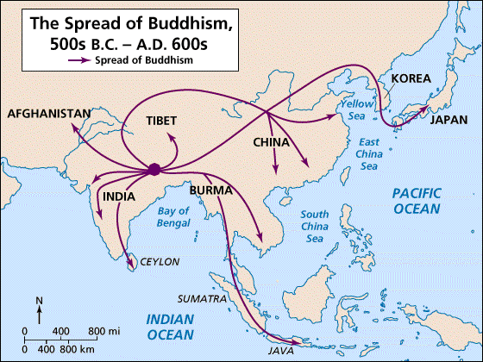
2. Based on the map below, what impact did the spread of Buddhism have on the current population of Asia today? (Where are most Buddhists found?)

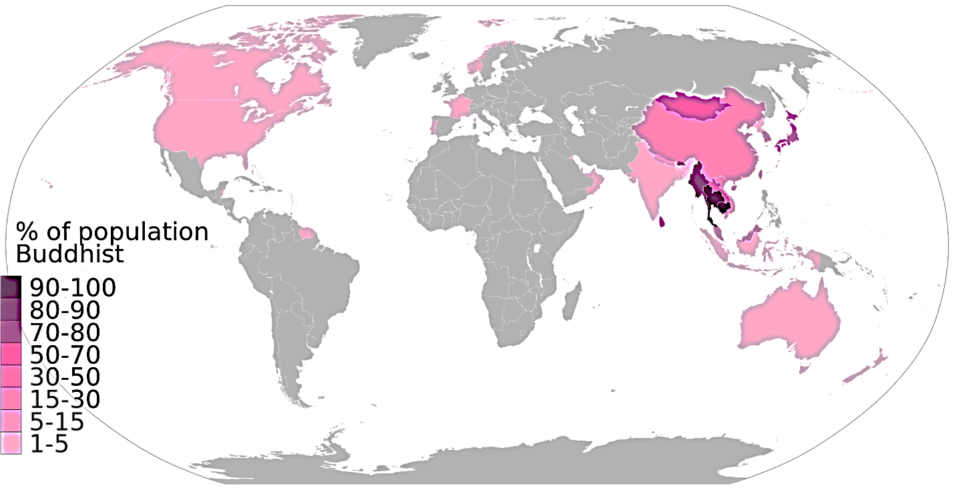

- Based on the map below, how did Hinduism impact the Indian subcontinent?

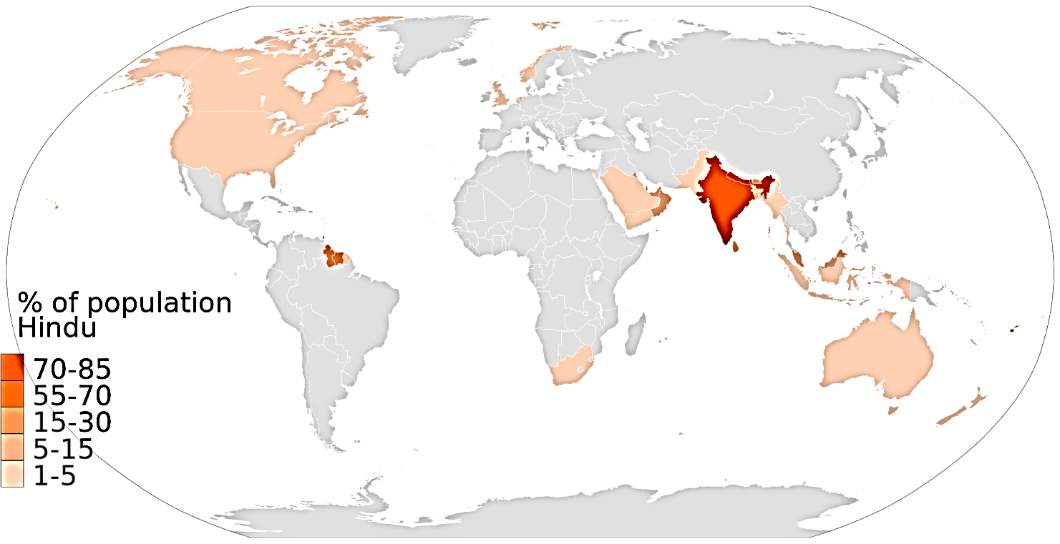

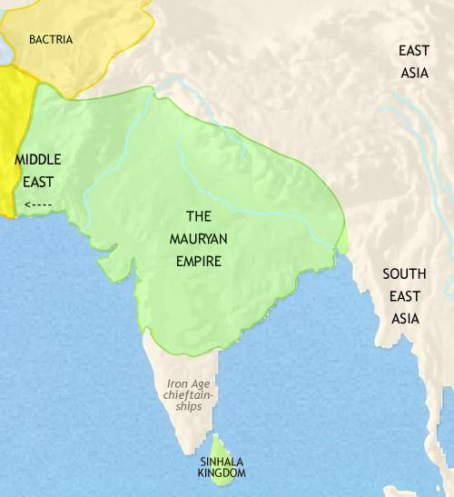

Mauryan Empire and Ashoka
Throughout most of India’s history, power was held in the hands of princes rather than great emperors like China. India was almost always united culturally through Hindu values even though there was political conflict. There were few times throughout Indian history in which the subcontinent was unified: Mauryan Dynasty, Gupta Dynasty (4th c.-6th c. CE), Mughal Empire (16th c), modern Republic of India.
In 322 BC, Chandragupta Maurya founded the Mauryan dynasty in present-day Eastern India. The central government formed by Chandragupta Maurya provided a stable, unified nation. This political and military unity used regional governors to control justice and security and let all kinds of trade expand and thrive. The trade that India engaged in along the Silk Road flourished because of the decreased number of bandits on the roads. Chandragupta also created a single currency.
Buddhism, practiced by the emperor Ashoka (became emperor after Chandragupta died), brought social and political peace to all of India. India had just experienced great war and devastation. Ashoka wanted Buddhism to replace Hinduism as the key belief system. Ashoka built 84,000 Buddhists buildings used as a place of meditation and this influenced Chinese and Japanese rulers who imitated Ashoka.
Despite Ashoka’s effort, Buddhism did not remain the key religion of India. Hinduism held a decentralized India together throughout the course of its history.

6. Why did trade increase during the time of the Mauryan Empire?

7. Why do you think Ashoka started to practice Buddhism (use prior knowledge of values of Buddhism)?

8. Why do you think Buddhism didn’t last in India?

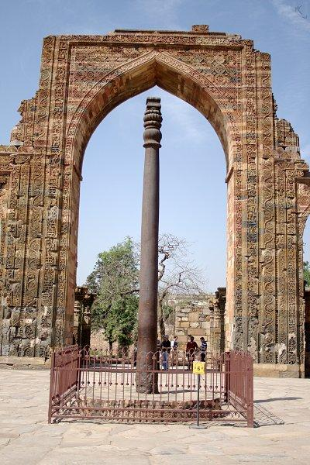
Golden Age of India
• After Asoka, Maurya empire collapsed and led to 500 years of conflict
• Gupta family took over—Chandra Gupta I (Different guy than Chandragupta Maurya) began rule 320 CE
• India had golden age during reign of Chandra Gupta II, 375-415 CE

Art and Literature
• Arts (architecture, murals, and statues) thrived under Chandra Gupta II
• Sanskrit (language of Hindus) plays, poems including love stories

Mathematics, Science, and Metal Working
• Indians invented our numeral and decimal systems, symbol for zero
• A mathematician figured length of year, value of pi (3.14)
• Doctors expanded medicine
• Artisans developed advanced metal working - included 23-foot iron pillar over Delhi - no others made a piece of iron as large until 1,000 years later

Trade Spreads Indian Culture
• Gupta India profited from foreign trade by selling cotton, ivory - bought items such as silk from China; resold to traders going west
• Traders and missionaries spread Indian culture, beliefs - Hinduism spread to parts of Southeast Asia - Buddhism spread to Central Asia, Sri Lanka, China, Southeast Asia

Application:
9. Why was the period of Gupta rule a golden age for India?

10. How did trade play a role in creating the “Golden Age” of India?

Why It Matters Now . . .
The spread of Hinduism and Buddhism shaped Asian cultures. Many Asian people still practice those religions today.

Chinese Timeline
Under the Zhou (Jo) dynasty, life in China was relatively decentralized (meaning no one emperor) with local lords ruling over their estates with peasant labor. In the Zhou dynasty, no one religion was dominant.
Following the fall of the Zhou, China faced a time of violence, chaos, and disorganization. This is referred to as the Warring States Period. During this time period new philosophies like Confucianism and Daoism emerged as a response to the chaotic time. Confucianism encouraged order through respect and Daoism reinforced balance with nature through meditation. Both of these ideas are reflective of the desire for order and balance in a chaotic time in Chinese history.
The next dynasty to restore order was the short-lived dynasty of Shi Huangdi in the Qin (Chin) Dynasty. Shi Huangdi had no successors and failed to create a true dynasty but did restore order through his harsh tactics. Shi Huangdi practiced Legalism, which enacted harsh punishments for violating any government law. Regardless of Shi Huangdi’s efforts to destroy Confucian and Daoist values, the two philosophies still influence Chinese history, government, and cultural practices today. The ideas of Confucianism also spread to Japan, Korea, and Vietnam.

Confucianism

Time Period
Warring States Period - Between Zhou and Qin Dynasties - 6th and 5th centuries BCE

Political History
- Dynasty
  - Series of rulers from the same family.
  - The last dynasty was the Qing (Ching) Dynasty which ended in 1911 CE. Since, China has been ruled by a variety of political systems.

- Mandate of Heaven
  - permission to rule from the gods. If they lost this mandate of heaven, the gods would make it known (through natural disasters and/or revolts) and the family would lose their right to rule.
- Dynastic Cycle
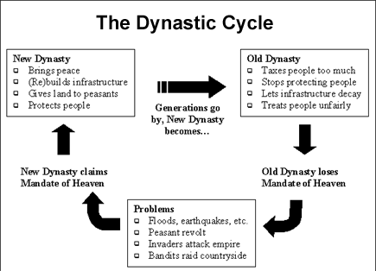

- Patriarchy
  - Male-dominance in Confucianism and the political system (male-heir)

Questions:
      - Why do you think Shi Huangdi attempted to outlaw Confucian texts?

      - Explain the rise and fall of Chinese dynasties according to the dynastic cycle.

      - Why was the dynastic system of China able to last thousands of years?

      - What is the Mandate of Heaven?

