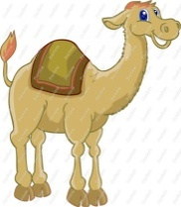
ARABIAN CULTURE BEFORE ISLAM

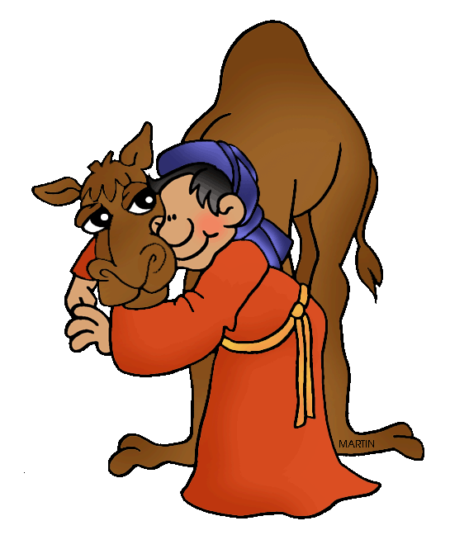
Before the birth of Muhammad, the majority of people living in the Arabian Peninsula were Bedouins (nomadic people). In their desert home, the Bedouin rarely got more than 10 inches of rain a year, and even that was undependable. So they had to live as nomads, roaming from place to place pitching their tents wherever there was water and grass for their camels, goats, and sheep. They jealously guarded their wells from other tribes. Bedouin warriors raided other peoples and fought one another over pastures and springs. In this hostile environment where farming was not possible, they valued their camels and swords above all else. Camels are exceptionally strong. A camel can carry a great burden up to 100 miles and go for eight days without water. They are essential for long-distance transportation across the desert. They also supply milk that is made into camel cheese. When the Bedouin wanted meat they slaughtered a goat. They also bred horses, which were prized for their swiftness in battles. The Bedouin occasionally traded their milk, cheese, meat, and skins with people who live in settled areas in exchange for crops and manufactured goods such as weapons, cloth, and saddles. Additionally, they gained needed resources by raiding settled farmers, fellow nomadic tribes, and caravan traders.
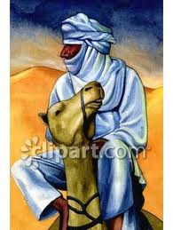
Few Bedouin could read or write, so the sharing of poetry and story-telling was important in this culture. They shared stories and poems about heroic deeds performed in their small, never-ending wars. The Bedouin were proud of their personal honor and independence. They were fiercely democratic. They fear any one person gaining too much power. As a result, the elders in a tribe met in a Tribal Council to make important decisions, especially about military matters. Women were allowed to participate, but very rarely, usually when decision involve marriage or child care. Every elder got to speak his mind, and usually the opinions of the best speakers carried the most weight. With so much warfare, however, strong leadership was critical to the welfare and survival of the clans and tribes. Every tribe had a shaykh (elder). This is the leader whose opinions matter the most in the Tribal Council. The shaykh often made crucial decisions for the tribe, though other tribal elders could reject the decisions of the shaykh. The shaykh was usually someone who came from a clan that was known for its leadership. The elders chose the shaykh and always selected a brave and strong warrior who knew how to lead others in battle. The shaykh had to be a good diplomat, because he was responsible for negotiating agreements with other tribes. He also had to settle disputes among the tribal elders. He was generally someone who was wealthy, by Bedouin standards, meaning that he owned many camels and horses. He was known for sharing his food and livestock, particularly with fellow clans-people whenever feasts were held.
Like other early peoples, the Bedouin believed in many gods. There was no single religion. People were scattered in tribes throughout the desert country. Each tribe had its own religion. Many tribes worshipped beastly sprites (elf-like creatures) or demons, who were believed to reside in trees, streams, and stones. These spiritual beings did not offer people guidance for proper behavior and conduct but could inflict punishment when displeased with people (e.g. sandstorm). A common practice among these polytheistic tribes was idol worship. Each tribe would have their own gods, goddesses, and objects that they considered to be holy. Because the Bedouin are nomads, they do not have permanent shrines or places of worship. There were a few places, like the Ka’ba in the city of Mecca where tribes would go to worship and store their idols for safe keeping.
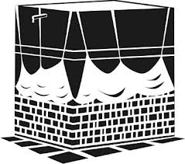
Mecca is located in a valley on the west coast of the Arabian Peninsula. It served as an important trading center to travelers heading north towards Constantinople and east towards Asia. A powerful tribe called the Quraysh gained control of Mecca and became wealthy by managing trade routes through the city in the 5th and 6th centuries. They negotiated treaties with people in neighboring areas that attempted to guarantee that trade caravans traveling through the robber-infested desert would be safe. By the 6th century, Mecca had become the most prosperous trading center in all of Arabia. Mecca also served as an important religious center. Long before the Quraysh settled in Mecca, local tribes came to the city to worship. Some of the tribes kept the idols of their gods in a low, cube-shaped shrine called the Ka’ba, which means “cube” in Arabic. According to some beliefs the original Ka’ba existed in Heaven. When Adam (from the Creation story of Adam & Eve) was forced to leave the Garden of Eden, he built a structure on Earth exactly like the one in Heaven. People also believed that the Ka’ba had a black stone embedded in its corner that was a gift from the Angel Gabriel to the prophet Abraham. The Quraysh encouraged tribes to deposit their idols inside the Ka’ba and promised to protect them for a fee. Religious Bedouin tried pray at the Ka’ba at least once during their lifetime. As the Quraysh became more powerful, they convinced all Bedouin to allow safe passage to all caravans in and out of Mecca during one month of the year (the month of Ramadan) so that people could safely travel to and worship at the Ka’ba. This holy month is called Ramadan. With a break in the fighting at least once a year, people were encouraged to trade in Mecca bringing increased wealth to the Quraysh.
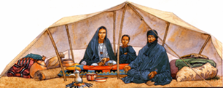
As a result of the increased trade and religious worship in Mecca the city became a place of great cultural diversity and exchange. The population included Arab tribes, Syrians who often worked as caravan leaders, merchants, traveling monks, Christians, and Jews.

*Adapted from History Alive! & The Medieval & Early Modern World Series

