Dead Poet Society Character List
Directions: while watching DPS, complete the chart on each main character of the movie.
Name | Image | Describe their personality before and after interactions with Keating | Example of their sense of self vs. an outsiders view of them
Mr. Keating
Neil Perry
Mr. Perry
Todd Anderson | 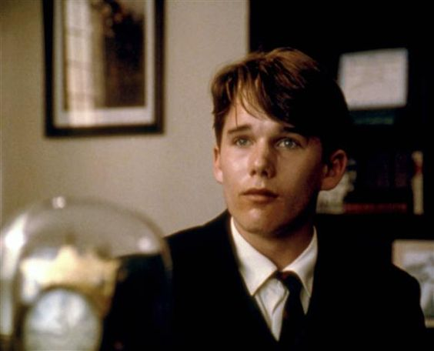
Knox Overstreet
Charlie Dalton
Richard Cameron | 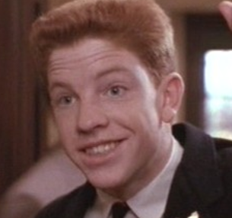
Steven Meeks
Gerald Pitts

