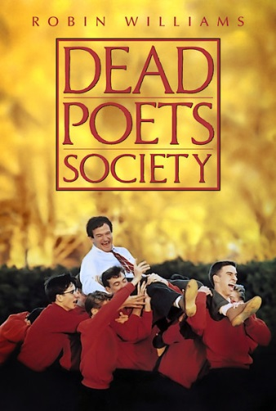
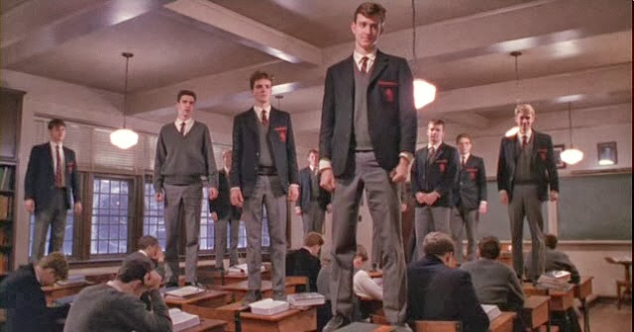
Dead Poets Society 5 Star Project

Due Date: Tuesday 10/31

Instructions: Choose any combination of activities below to earn 5 stars. The learning opportunities below are grouped according to level of challenge. More stars are awarded to the more challenging activities. Choose either the ‘A’ option or ‘B’ option or both to get the star amount. If you choose both obviously you get double the star value.

One Star Opportunities
1A
Create a Venn Diagram comparing and contrasting Sprayberry to Welton. Must include 5-10 examples in each part of the Venn Diagram.
1B
Now that you have lived the “public school” life and have seen the boarding- extreme private school life, create your perfect school. You need to include the following; Are you a public (accepting of everyone that lives in the area) or private (people have to apply to attend your school- you have a certain standard and will only accept students who meet that criteria)- if private establish what will the criteria be for students to attend, School Motto, School dress code, what will your punishments be for students who break the rules, would you change or add any new curriculum maybe not offered at Sprayberry?
Two Star Opportunities
2A
Deviance simply means to break the standard norm of a given group. Why do you think students at Welton became deviant? Was it because Welton tried to resocialize them/ was a total institution? In your opinion, would this deviance have been so prevalent in a public school…why or why not? In other words, do more rules = more rebellion? Be sure to give specific examples of rebellion and use specific terminology and vocabulary from the unit.

2B
Write a short answer (5-7 sentences) comparing and contrasting the peer socialization the boys experienced at Welton vs. the socialization they were experiencing from their peers. What elements were similar? What were different?

Three Star Opportunities
3A
Create a looking glass image through the eyes of Neil Perry. On the stick figure you will draw the way he views himself, in the mirror you will draw either how his father views him, Mr. Keating, or his peers (circle on the sheet which one you drew).
3B
Create a looking glass image through the eyes of Todd Anderson. On the stick figure you will draw the way he views himself, in the mirror you will draw either how his father/family views him, Mr. Keating, or his peers (circle on the sheet which one you drew).

Four Star Opportunities
4A
Analyze the movie from one of the three sociological perspectives. While viewing the movie from that perspective what would a sociologist notice or pay attention to? What would they express as the problems in the movie between the characters and outside forces etc. This should be a through explanation of one of the perspectives and include 2 examples/scenes from the movie they would be particularly interested in.

