Napoleon Bonaparte : A Hero or A Tyrant?

Overview: Napoleon was a man of Great power in France. When the French Revolution began, Napoleon saw this as a way to get involved. He was part of a group called the Directory that ran the government. In this group he quickly gained power. Some of his responsibilities were: control the army, directed law making, oversaw foreign power and appointed government officials. Napoleon then declared himself Emperor and started new policies that would stay with France forever.

Hook Exercise: Napoleon Bonaparte
Directions: During Napoleon's reign as Emperor of France he kept a book of all his quotes that showed his attitude on topics such as war, politics, public opinion, and how to rule the people. They would be later known as Napoleon's Maxims.

Read the quote below and consider the following questions.
“The surest way to remain poor is to be honest”
- Napoleon Bonaparte's Maxims

Questions:
1. What type of attitude does Napoleon have with this quote? What does it mean?

2. From the quote, what type of life do you think Napoleon led?

3. Do you think that Napoleon intended for people to see quotes like the one above? What type of opinion does this quote give you about Napoleon as a person? Explain.

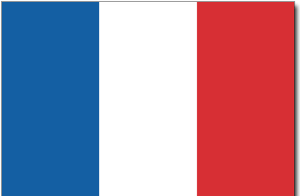

Background essay

Napoleon Bonaparte: Hero or Tyrant?
Napoleon Bonaparte was born on August 15 in Ajaccio, Corsica, the second oldest of 8 siblings. His birth occurred just 3 months after the French took over Corsica. As a child, he hated France. His father, Carlo, on the other hand, was a poor French aristocrat. Napoleon didn’t like his father for taking the French side instead of the Corsican side. Letzig, his mother was very strict. She taught the kids sacrifice and discipline. Sometimes Napoleon had to go to bed without supper. Carlo worked very hard so Napoleon could go to the private academy, Brienne, in 1776 which was located in France. He was very good at math and science. Then he went to a military school in France.

In 1779, he became an officer in the French artillery and a master war tactician. As an adult he was only 5 feet 6. Then Napoleon was promoted because of his victory over the British. One year later, in 1780, he was put in jail for a military failure. The following year, Napoleon was asked by the new government to stop a mob of Parisians trying to overthrow them. When the mob came down the street, Napoleon fired his cannons, killing many of them. That stopped them! The government rewarded him by giving him the army of Italy.

He had many military successes in Italy, but made himself look like a hero by writing army reports that exaggerated his achievements. After success in Italy, he conquered Egypt, but eventually he lost in Syria, so he abandoned his army and returned to France to take control of the weak government. He used the French Revolution as his opportunity to get power.

When Napoleon returned to France in 1804, because of his reports that made him seem so great, he became emperor. As emperor, Napoleon achieved a lot for France. He introduced a new government, the Consulate. During this period he created the Banque de France, official Bank of France to achieve economic growth, the Legion d'honneur, chivalry code for civilians and soldiers, Civil Code, new laws France still uses today, and reformed the school system.

Although Napoleon had lost some battles, he fascinated the French people by telling them about the strange land of Egypt.

Napoleon still did not have a child with his wife, Josephine. He wanted an heir to his throne, so he divorced her and married the daughter of the Austrian king. She had his son, Napoleon II, soon after that.

Throughout the early 1800’s, Napoleon fought various battles against many European countries, called the Allies. Most of the European countries were captured by Napoleon’s army. While under the French control these countries had to pay taxes and send all their young men to fight in Napoleon's army. They eventually rebelled. When he tried to take over Russia, he was able to occupy Moscow, but his army was caught in bad weather. Having no resources, they had to retreat and return to France.

By April of 1814, he was forced to step down from power by the Allies and was exiled to the island of Elba. The King was then restored to the French throne.

In 1815, his soldiers helped him come to France and become emperor once again. Before the Allies could attack him, he attacked them. When Napoleon was defeated at the battle of Waterloo, he took the failure upon himself and gave himself to the British. The British exiled him to the Island of St. Helena and there he died in 1821.

Background Essay Questions
1. What was the first event to promote Napoleon within the military?

2. Why did the French government give Napoleon his own army in Italy?

3. What made him look like a hero to the French government?

4. Why did he abandon his army in Egypt?

5. What achievements did Napoleon bring to the French government under his reign?

6. Why did the European countries rebel against Napoleon?

7. What happened to Napoleon after the Allies fought back?

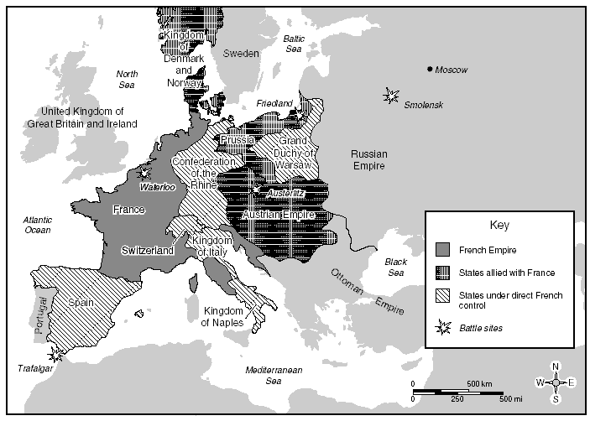
Document 1: Napoleon's Conquests of Europe during his reign as Emperor of France.
1. What countries did Napoleon conquer?
2. What do you believe is the difference between being allied with France vs. being under direct French control?

3. What countries do you think Napoleon had the hardest time taking over during his conquests?

Document 2 : Napoleonic Code
CHAPTER II. Of the Privation of Civil Rights.
SECTION I.
Of the Privation of Civil Rights by the Loss of the Quality of Frenchman.
…17. The quality of Frenchman shall be lost, 1st, by naturalization in a foreign country; 2d, by accepting, without the authority of government, public employments bestowed by a foreign power; 3dly, by adoption into any foreign corporation which shall require distinctions of birth; 4thly, in short, by any settlement made in a foreign country, without intention of return.

- What are the four ways that you can lose French citizenship with this law?

- How is this law going to change the behavior of the French people towards their country?

- Napoleon thought that this law was very important. Do you think this law was for his gain in society as a leader or for the people themselves to come together as one? Explain your answer.
Document 3: Napoleon himself explained to the Council of State in 1802 his philosophy on how he governs his country.

"I govern not as a general but because the nation believes that I have the civilian qualities necessary to govern. If I did not have this opinion, the government could not stand."

1. What does Napoleon say about how he is so successful in governing France?

2. If Napoleon did not have this attitude about his way of governing, What would happen to the government of France?

3. If you were part of the Council and heard this quote from Napoleon's speech, What opinion would you have of him? Explain.

Document 4: Alexis de Tocqueville(close friend of Napoleon) wrote:

Napoleon "fell, but what was really substantial in his work lasted; his
government died, but his administration continued to live..."

1. What is this quote saying about Napoleon's success? Explain.

2. When the quote says, “Napoleon fell, but what was really substantial in his work lasted”, What does the speaker mean?

3. In this quote, Do you think the author thought that Napoleon was great or a failure in France? Explain your answer.

Document 5: Great Britain was Napoleon's greatest enemy. Great Britain was a major world power until Napoleon came around. When Great Britain decided to try to make Napoleon look bad, Napoleon had to fight back. Napoleon used the Continental System against Great Britain, that was a blockade that forbids the imports of British goods into Europe. His hopes were to cut British trade and starve the country into defeat.

1. What are some advantages for France with the Continental System? Give at least 2 and explain them.

2. What are some disadvantages for France with the Continental System? Give at least 2 and explain them.

3. Why would Napoleon think that he could starve Great Britain into defeat by looking at the map?

