The Scramble for Africa
Africa before European Domination; Forces driving Imperialism
WHY did imperialism begin in the 1800’s
In the early 1800s, Europeans controlled a few areas along the coast of Africa. By the mid-1800s, Europeans were expanding their control to new lands. This policy is called imperialism. There were four basic reasons for imperialism. The first reason for imperialism had to do with the economy. Europeans wanted colonies to provide raw materials for their factories. The Europeans also wanted to sell their goods in the new colonies. Nationalism was a second reason for imperialism. Some nations wanted to gain colonies to show their national strength. Ideology was a third reason for imperialism. Racism is the belief that one race is better than others. Many Europeans believed that whites were better than other races.
Racism is related to Social Darwinism. Social Darwinism is the use of Charles Darwin’s ideas about evolution to explain human societies. One of Darwin’s ideas was “survival of the fittest”. This idea was that the fittest, or strongest, species would survive. Weak Species would not survive. People who believed in Social Darwinism argued that fit people and nations survived. They also believed that weak people and nations would not survive.
Christian missionaries also supported imperialism. They thought that European rule would end the slave trade. The missionaries also wanted to convert the people of other continents to Christianity. Europeans began to take lands in Africa for these reasons.
Technology was the final cause that helped the Europeans succeed. By 1850, the commercialization of quinine, a drug derived from the bark of the Peruvian cinchona tree, made it possible for Europeans to invade tropical lands without heavy death rates from malaria. More devastatingly, the weapons gap between Europe and the rest grew tremendously with the introduction of breech-loading and repeating rifles and, deadliest of all in that period, the Maxim gun (early machine gun). The African peoples were divided. It was hard for them to resist European advances.
- What are four reasons for imperialism? ______________________________________________________ ______________________________________________________________________________________________________________________________________________________________________________________________
The Division of Africa
How did European nations claim African Lands?
The “scramble for Africa” began in the 1880’s. Diamonds were discovered in South Africa in 1867. Gold was discovered there in 1886. Europeans became more interested in the continent. The European nations did not want to fight over the land. They met at the Berlin Conference, in 1884-85. They agreed that any nation could claim any part of Africa by telling the others and by showing that is had control of the area. Europeans quickly grabbed land. By 1914, only Liberia and Ethiopia were free from European control.
- What was the purpose of the Berlin Conference? _______________________________________________ ________________________________________________________________________________________

Three Groups Clash over South Africa
What groups fought over South Africa?
In South Africa, three groups struggled over the land. In the early 1800’s the Zulu chief Shaka fought to win more land. Shaka’s successors were not able to keep his kingdom intact. The Zulu land was taken over by the British in 1887. Meanwhile, the British took control of the Dutch colony on the southern coast. Thousands of Dutch settlers, called Boers, moved north to escape the British. This movement is known as the Great Trek. The Boers fought the Zulus whose land they were entering. At the end of the century, Boers fought a vicious war against the British called the Boer War. The Boers lost this war. The Boers then joined the British-run Union of South Africa.
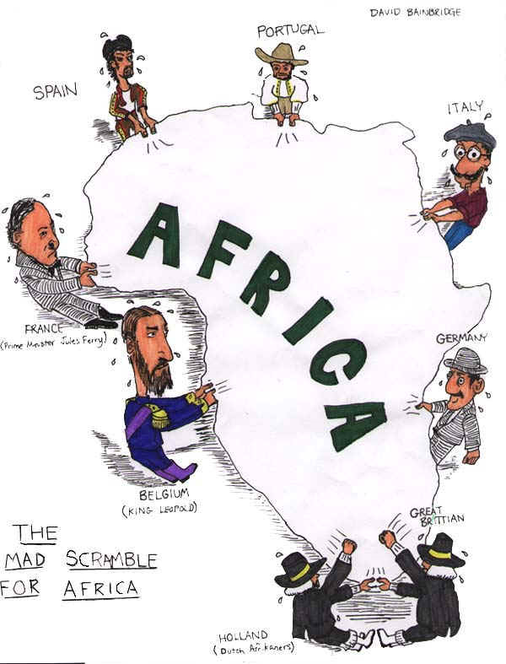
- Who were the Boers, and whom did they fight? _________________________________________________ ________________________________________________________________________________________
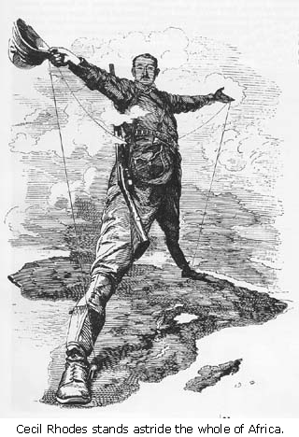
1. What continent is the man standing on?______________________________________________________________
2. Who does this man represent? _____________________________________________________________________
3. What does this cartoon indicate about the ambitions of this man?__________________________________________

