Unit 5 Opening Warm-up
Now that you have read about Machiavelli’s ideas about how a Prince/King should rule and after debating about what qualities a Captain needs to possess to be a good leader, list qualities you think a King should possess to be a good ruler.
- __________________________________
- __________________________________
- __________________________________
- __________________________________
- __________________________________
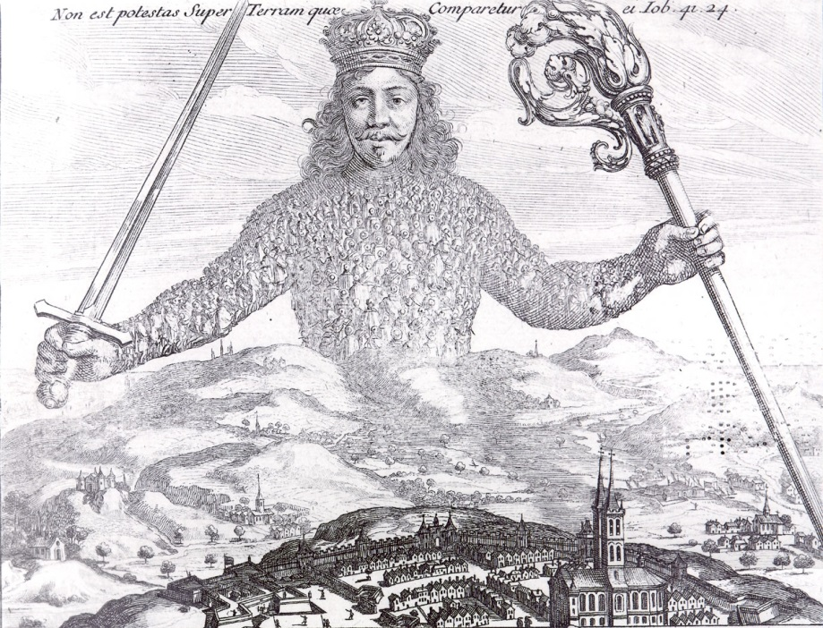

Question 1
These ideas were expressed by King James I of England in 1609:
The state of monarchy is the supreme thing upon earth; for kings are not only God’s lieutenants on earth, and sit upon God’s throne, but even by God Himself they are called gods… Kings are justly called gods, for that they exercise a… divine power upon earth… God hath power to create and destroy, make or unmake at His pleasure, to give life or sent death, to judge all and to be judged nor accountable to none, to raise low things and to make high things low at His pleasure… And the like power have kings…

1. What idea does King James describe in this document and why does he feel government should be organized in this way?

Question 2
These ideas were expressed by King Louis XIV of France in 1660:
The head alone has the right to deliberate and decide, and the functions of all the other members consist only in carrying out the commands given to them… The more you grant… [ to the assembled people], the more it claims.. The interest of the state must come first.

2. What type of government does King Louis describe and why does he recommend this type of government?

Question 3
Compare and contrast your views of how a King should rule to King James I and King Louis XIV expressions of how a king should rule.

