ECONOMIC EFFECTS OF THE INDUSTRIAL REVOLUTION

Standard: SSWH15 a. Analyze the process and impact of industrialization in England, Germany, and Japan,
movements for political reform, the writings of Adam Smith and Karl Marx. . .
What am I learning today? What are the major advantages and disadvantages of Adam Smith’s free market
capitalist economy and Karl Marx’s communist system?
What will I do to show I have learned it? I will . . . participate in the free market capitalism game, contribute
in the class discussion, complete the graphic organizer notes, answer the questions to
the cartoons to formatively asses my understanding of the topic.

In industrialized countries in the 19th century, the Industrial Revolution opened a wide gap between the rich and the poor. Disagreements existed about the role of the government in business and economic affairs. What do you think?
 | Free Market Capitalism | Communism
definition
Author + Book | author: _________________________  book title: _______________________ | author: _______________________  book title: _____________________
Other Names For It

What Makes It Work?

Positive Characteristics
Negative Characteristics
Concept of Equality

Answer the following questions:

Do you think business owners tended to favor laissez-faire capitalism OR communism? Why? ______________
__________________________________________________________________________________________

Do you think factory workers tended to favor laissez-faire capitalism OR communism? Why? ______________
__________________________________________________________________________________________
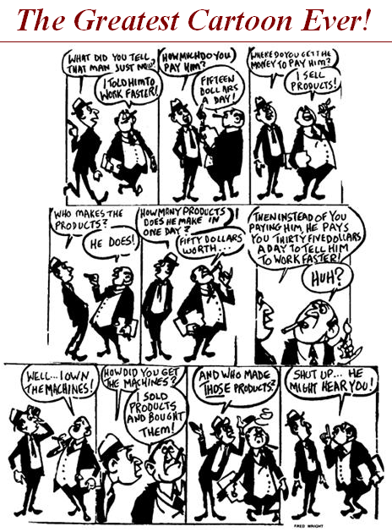

1a Do you think the cartoonist supports communism OR free market capitalism? Explain.
_____________________________________________________________________________________________________________________________________________________________________________________________
___________________________

1b The bourgeoisie, business owners, look bad in this cartoon, but what might you say to defend them?
__________________________________________________________________________________________________________________________________________________________________
___________________________

Example Test Question:

Laissez- faire economics stemmed from French economic philosophers of the Enlightenment. The term laissez faire refers to the economic policy of
- Demanding all industry and business be government-owned and operated
- Allowing for strong government involvement in the setting of working conditions for industry and business.
- Letting owners of industry and business set working conditions without government interference
- Requiring that owners of industry and business not set any working conditions

