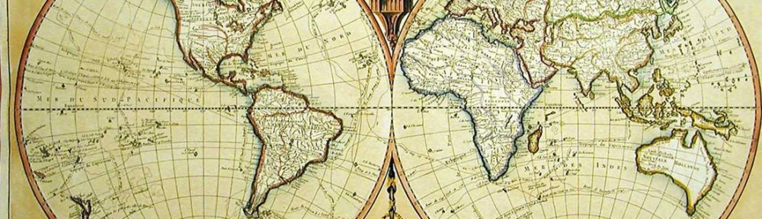
World History ABC Book

Checklist—Your book should contain the following information:
- A decorated/colored cover with your name as the author. Be sure to decorate it with World History content/terms/images.

- Each letter of the alphabet should be on it’s own separate page. (‘x’ maybe a word that starts with ‘Ex’)
  - You may use any word or term discussed in this class that relates to World History (people, place, event, battle, leader, religion, vocab term etc.) should correspond to each letter of the alphabet. Hint: your objectives are a good resource to use for this

- A thorough definition or explanation of each word (2-3 sentences!) written in terms that a younger child could understand. EVERYTHING must be HAND written!

- An illustration for each word, must be colored.
  - Illustrations can be drawn, traced, copied, or printed.

- Be consistent throughout your book. Make it as much like a real ABC book as possible.

- Spelling and grammar count.

