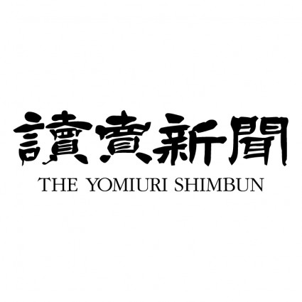

***Atomic Bombs Hit***

**Directions: The Japanese and Americans had very different takes on the events happening in the Pacific. Create an appropriate headline for each, and write one paragraph describing the event taking into consideration both perspectives of the war.**

(Write Japanese headline for Newspaper here)

(write American Headline for newspaper here)

caption: (appropriate caption to image in Japanese newspaper)

caption: (appropriate caption to image in American newspaper)

|  |  |  |
| --- | --- | --- |
| (Write paragraph about event from American Perspective here) |  | (Write paragraph about event from Japanese perspective here) |

(Insert image here) (Insert image here)